# 1. INTRODUCTION :

## Overview :

Created and Hosted a Food and Drink Website.(TENOR CAFE)

## Purpose :

To let customers know the taste and the types of food available.

# 2. LITERATURE SURVEY :

## E**xisting Problem :**

Many times we got stuck while hearing the name of certain food and drink items(in my case, COFFEE) and sometimes we can't differentiate between certain food itmes.

## Proposed Solution :

I have created a Coffee Website where I have listed varities of Coffee Essence and eeven provided steps for few that how one can know about varities of coffee, whose name was also rare till now.

# 

# 3. THEORITICAL ANALYSIS :

## Block Diagram :

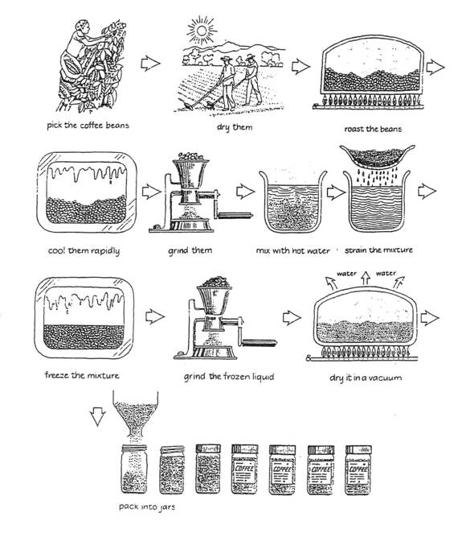

# 

# 4. ExPERIMENTAL INVERTIGATIONS :

I have reached to a point that Ther are many types of Coffee, whose names I also haven't heard till date.   
And as far, We all are living in such high socities that its not very rare for most of us to know the names of types of Coffee, so, I have come with a Website (TENOR CAFE), where I have listed few types of Coffee that we can see in our daily life, and whoser taste and name has been still unknown to us.

So I have just created a website for those problem statements.

# 

# 5. FLOWCHART :

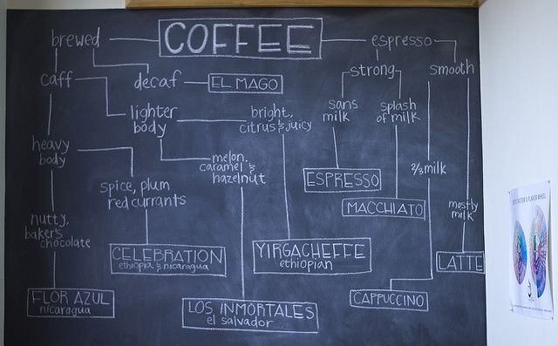

# 6. RESULTS :

As, I have already told enough about my website.

Now, Let me present Few Screenshots as how my website exactly look like.

**My HOMEPAGE, and Another Pages which I've created**

**All my Pages are shown below:-**

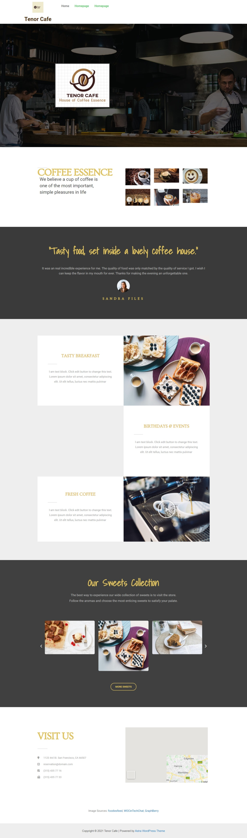

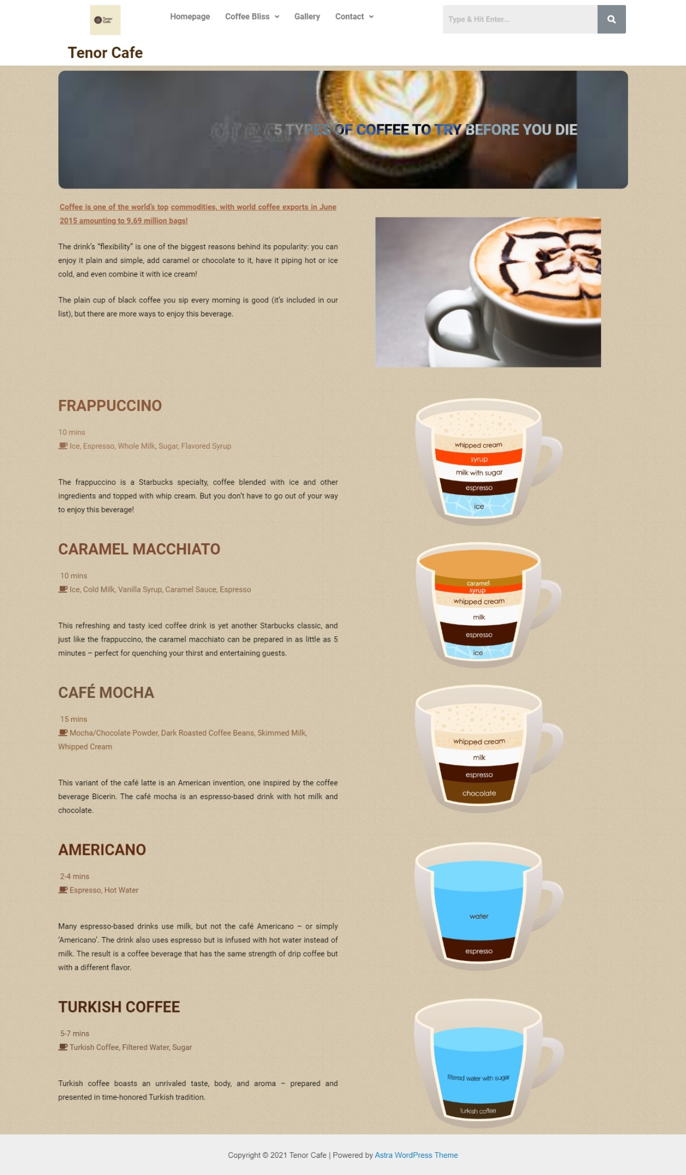

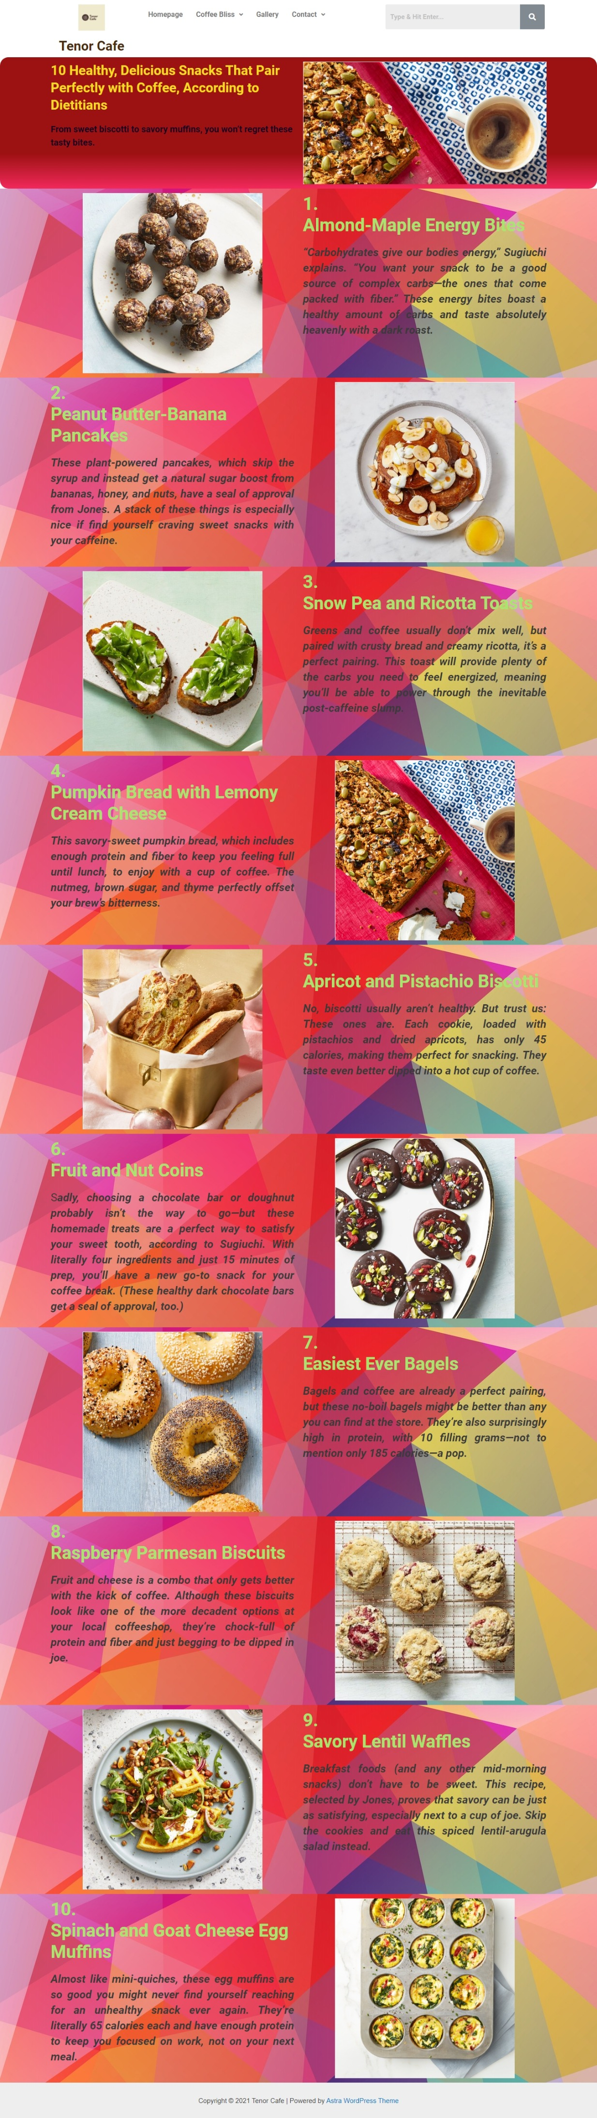

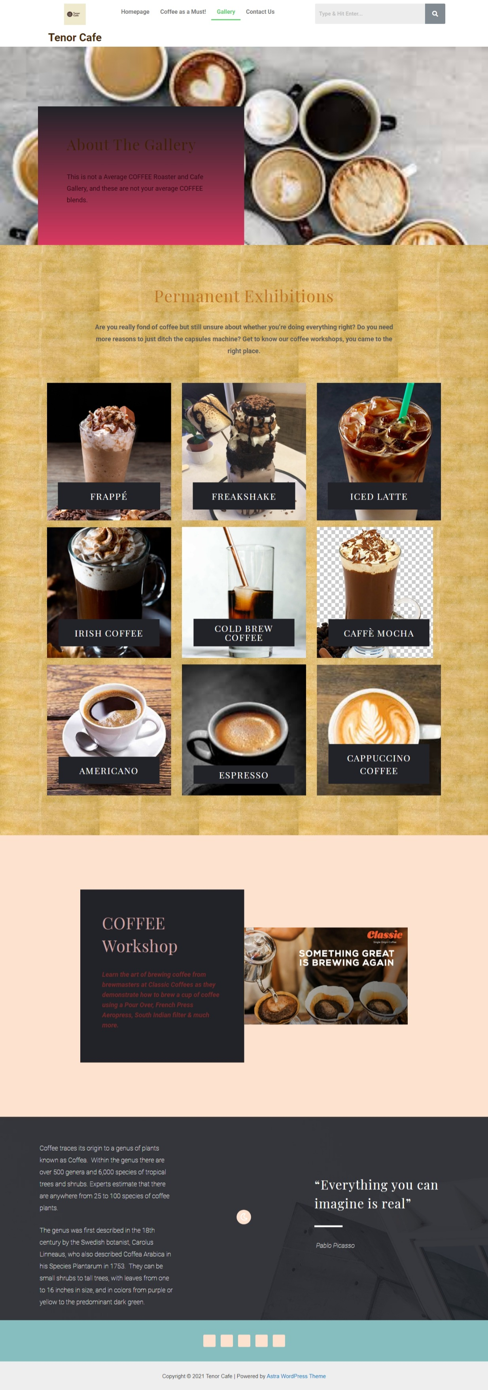

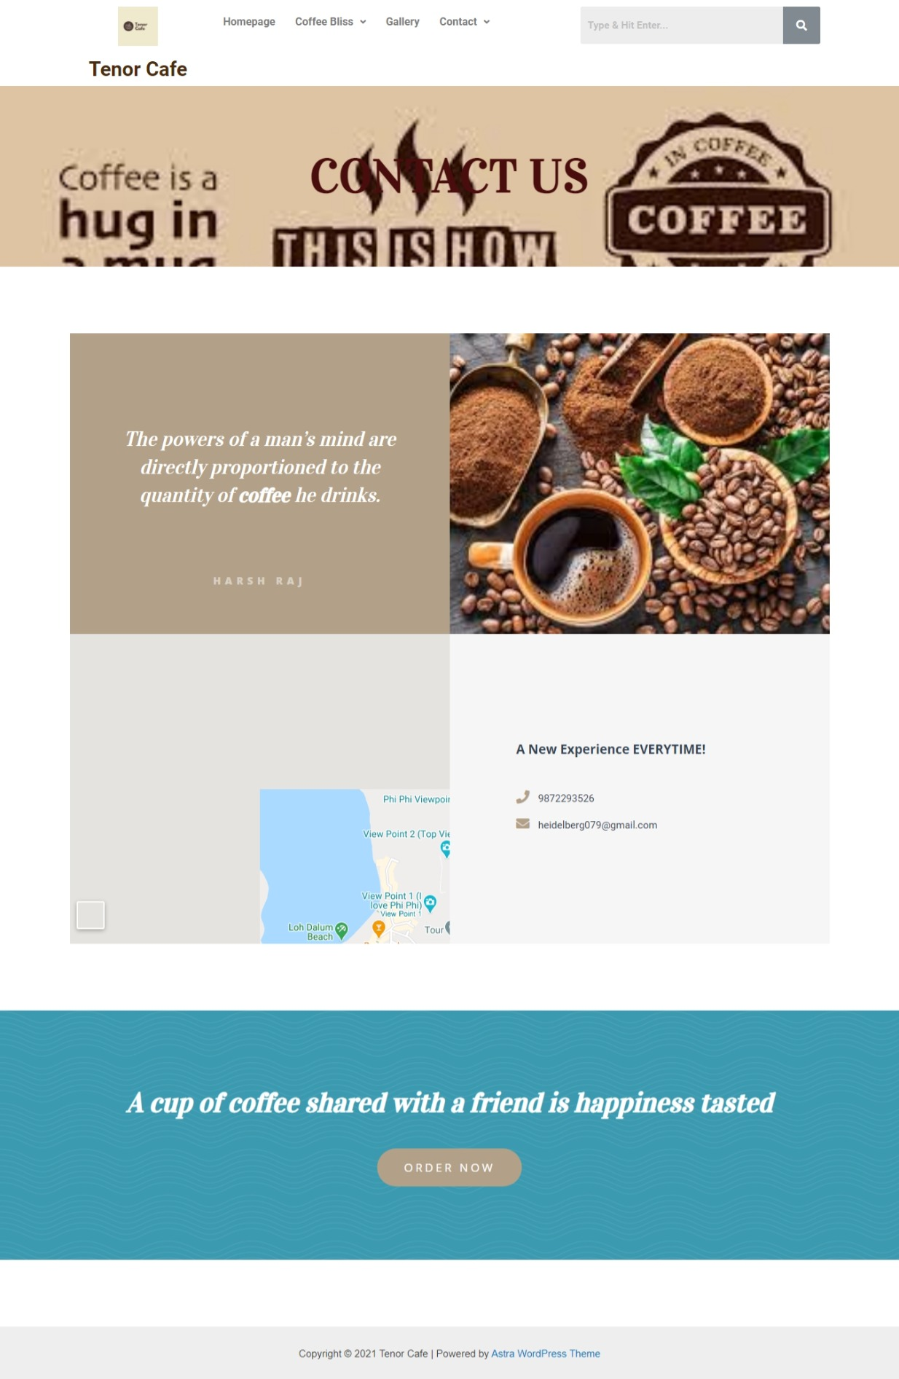

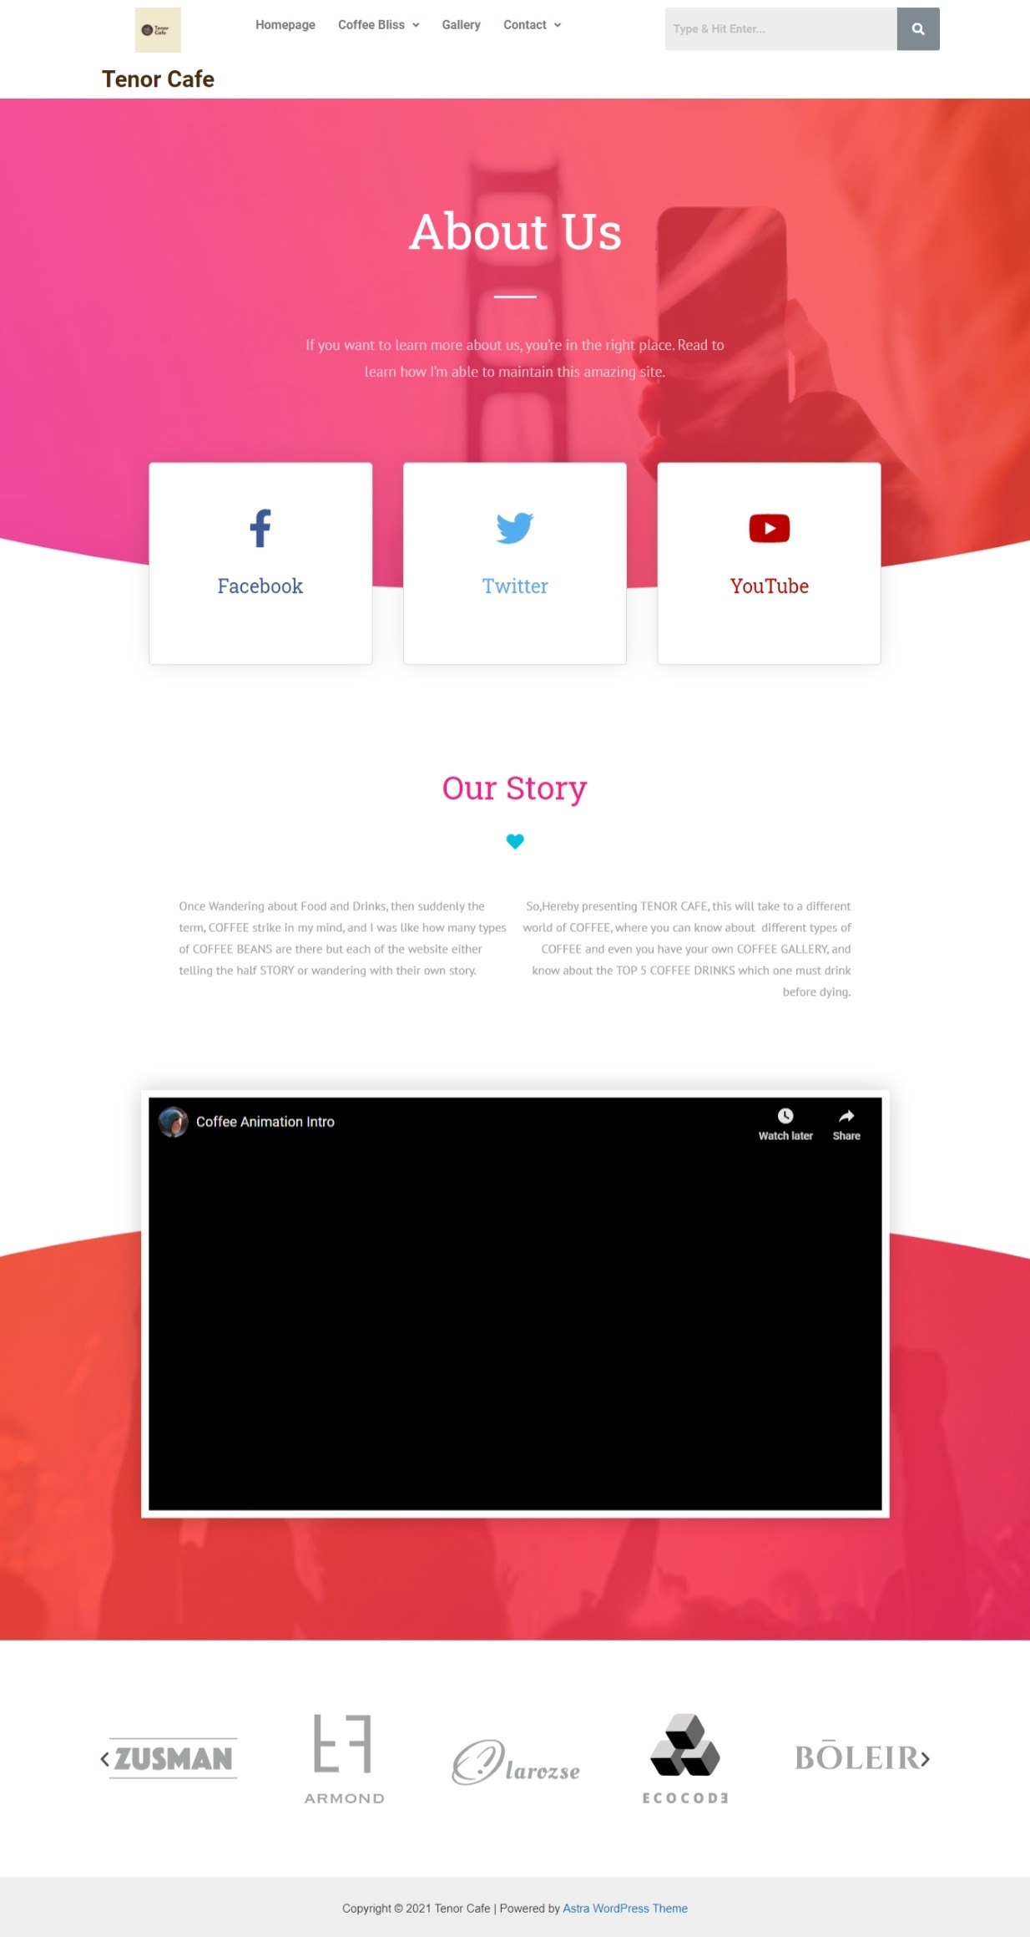

# 7. ADVANTAGES & DISADVANTAGES :

**Pros: One can know a lot about my Coffee visiting my website.**

**Even they can know what healthy and delicious food to be taken with that.**

**Cons: Well, I cannot see any disadvantage from my proposed solution,**

**but my websites don't have almost all Coffee Drinks and All the COFFEE Beans found all**

**over the globe.**

# 8. APPLICATIONS :

As I have already mention, Its a COFFEE Essence Website, one can know a lot about COFFEE from my website.

So, MY PROPOSED SOLUTIONS ARE FOR THOSE ENTHUSIATS, who know the IMPORTANCE OF COFFEE IN THEIR EVERYDAY LIFE.

# 9. CONCLUSIONS :

I conclude by saying that My Website(TENOR CAFE) can help one to know a lot about different types of COFFEE present all over the globe.

# 10. FUTURE SCOPE :

As, we all know that the World is developing way too fast, and so, we all get to know about a variety of things daily, and so In the Rusk=hing World, COFFEE plays a very important role in our daily life, but we should know, which COFFEE plays what role, and here comes the role of my website, one can get much info about different types of COFFEE.

# 11. BIBLIOGRAPHY :

PREVENTION WEBSITE https://www.prevention.com/food-nutrition/g20452602/healthy-snacks-to-eat-with-coffee/

PREVENTION WEBSITE

https://www.prevention.com/food-nutrition/g20452602/healthy-snacks-to-eat-with-coffee/

Taken photo of various COFFEE drinks and COFFEE BEANS from Google and Bing.